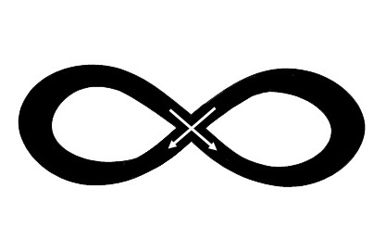

**Partner 2 _______________**

**Behavioral Trigger** *(When you pursue or withdraw by)*



**Relationship Message** *(I hear this as a message saying)*

**Secondary/Surface Emotion** *(Then I feel)*



**Primary Emotion** *(But underneath I really feel)*

**Unmet Attachment Needs** *(Because what I long for is)*

**Reactive Behavior** *(So in response what I wind up doing is)*

This should match Partner 1’s behavioral trigger



**Partner 1 _______________**

**Behavioral Trigger** *(When you pursue or withdraw by)*

**Relationship Message** *(I hear this as a message saying)*

**Secondary/Surface Emotion** *(Then I feel)*



**Primary Emotion** *(But underneath I’m really feeling)*

**Unmet Attachment Needs** *(Because what I long for is)*

**Reactive Behavior** *(So in response what I wind up doing is)*

This should match Partner 2’s behavioral trigger